Alexa Voice Integration Initial Set-Up
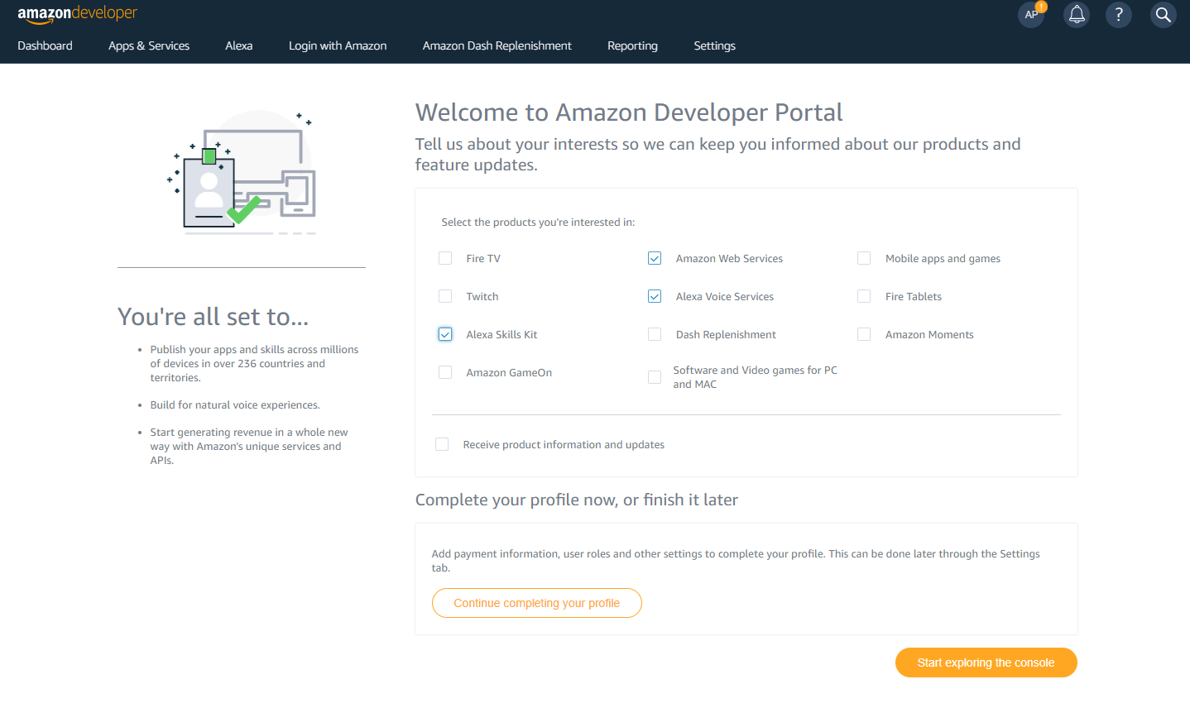
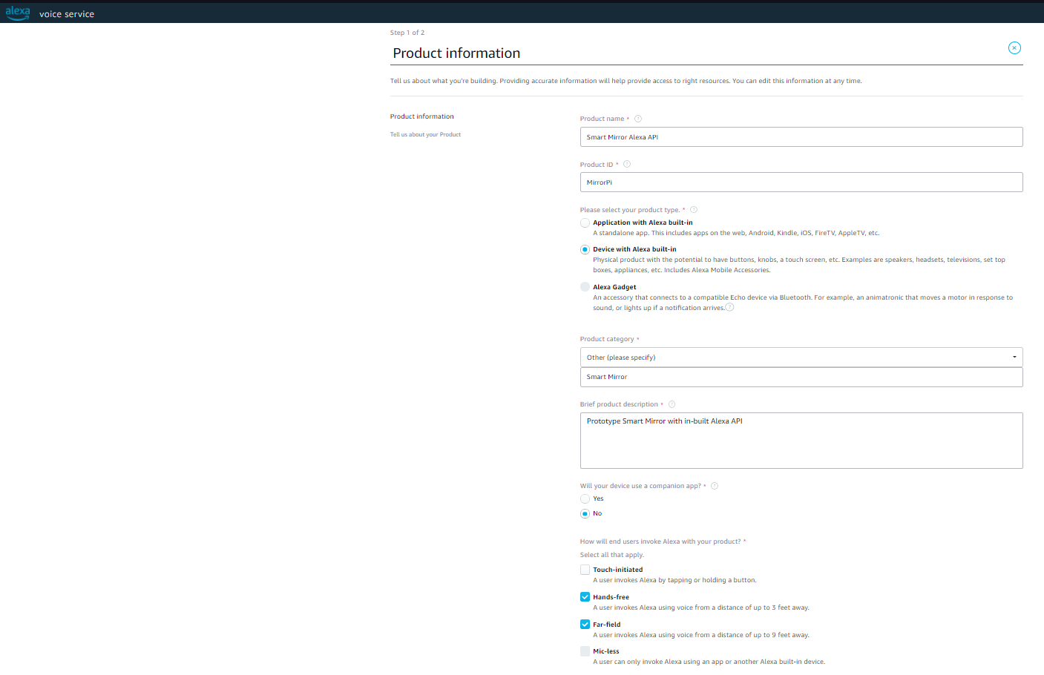
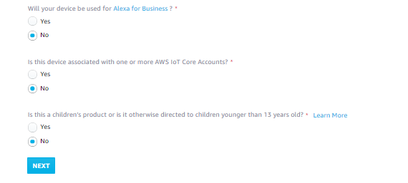
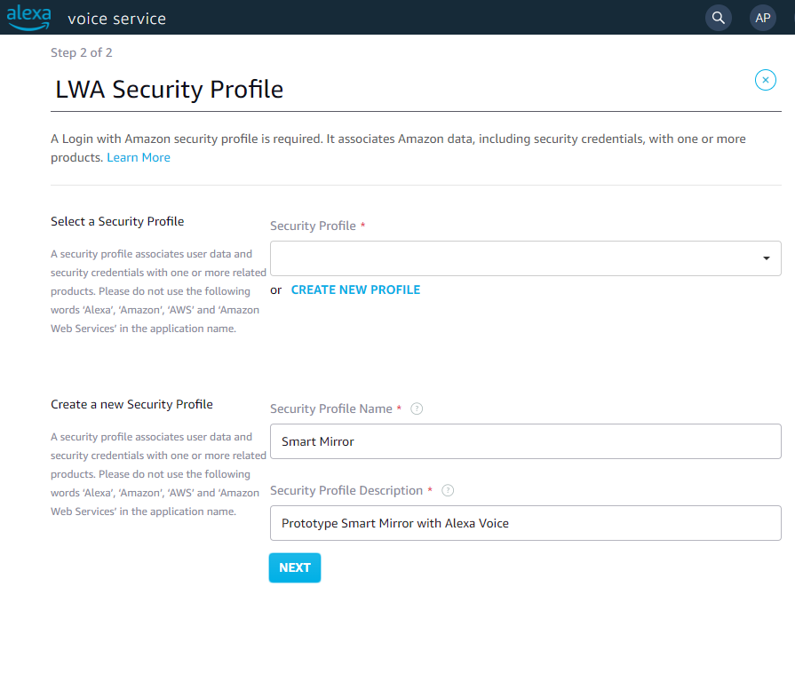
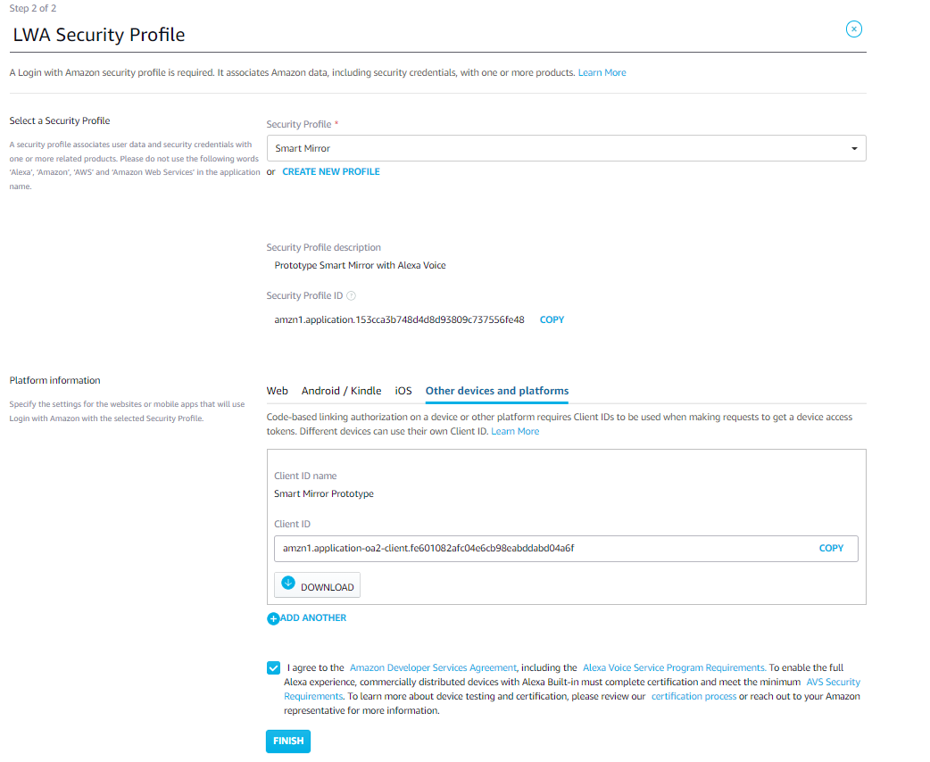
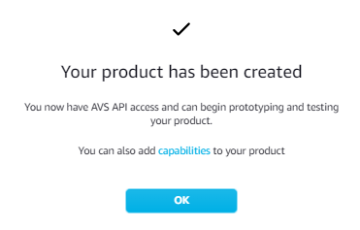
Resources:

Register a Product
This tutorial teaches you how to register an Alexa Voice Service (AVS) Built-in device with the Amazon developer portal. You complete the following activities in this tutorial:
- Create an Amazon developer account.
- Register an AVS built-in device.
- Set up your security profile.
When finished, you download the required security credentials to connect your device to AVS.
Optionally, continue with step two of the tutorial to set up the AVS Device SDK on a Raspberry Pi. This tutorial uses a handful of scripts to download, build, and run the SDK with wake word detection enabled. When finished, you have a working sample app to test interactions with Alexa.

Create an Amazon developer account
Create a free developer account at developer.amazon.com. If you already have an account, you can skip this step.

Create a product
After you've created an Amazon developer account, you create a product and security profile. This authenticates your software client so it can connect to AVS.
To create a product
- Log in to the AVS dashboard.
If this is your first time registering a product, you see a welcome screen. Click GET STARTED.
- Click PRODUCTS.
- Click ADD NEW PRODUCT.

Fill in product information
You now must fill in your product information. This information identifies your device with AVS.
Note: These instructions are for developers prototyping on a Raspberry Pi. If you are registering a commercial product, use your own custom information here.
To fill in your product information
- Choose a Product Name. For example, AVS Tutorials Project.
- Choose a Product ID. For example, PrototypePi. Don't use any spaces in your product name.
- In the Please Select Your Product Type dropdown, select Device with Alexa built-in.
- For Will your device use a companion app?, choose No.
- In the Product Category dropdown, select Other (please specify).
- Write a meaningful description in the Brief product description box. For example, Prototype.
- Under How will users interact with your product?, select Hands-free.
- Skip the Upload an image step. This isn't required for prototyping.
- Under Do you intend to distribute this product commercially?, select No.
- Under Will your device be used for Alexa for Business?, select No.
- Under Is this device associated with one or more AWS IoT Core Accounts?, select No.
- Under Is this a children’s product or is it otherwise directed to children younger than 13 years old?, Select No.
- Click NEXT.

Set up your AVS security profile
A login with Amazon (LWA) security profile associates your security credentials with your product.
To set up your security profile
- Click CREATE NEW PROFILE.
- Under Security Profile Name, enter a relevant name. For example, AVS Tutorials Project.
- Under Security Profile Description, enter a relevant description. For example, AVS Tutorials
- Click NEXT. Your Security Profile ID generates.
- Select the Other devices and platforms tab.
- Under Client ID name, enter a relevant name. For example, Prototype.
- Click Generate ID.
- Click Download. This downloads your config.json file that contains your AVS credentials. Save the file to your /home/pi directory. If you are creating this profile from a different PC, you must transfer it to your Raspberry Pi.
- Read the Amazon terms and conditions. If you agree, check the I agree to the AVS agreement and the AVS Program Requirements box.
- Click FINISH. Congratulations! You now have access to AVS.
- A pop-up appears. Click OK. You can now view your device on your AVS dashboard.
The following screenshots highlight the important steps described in the previous section.
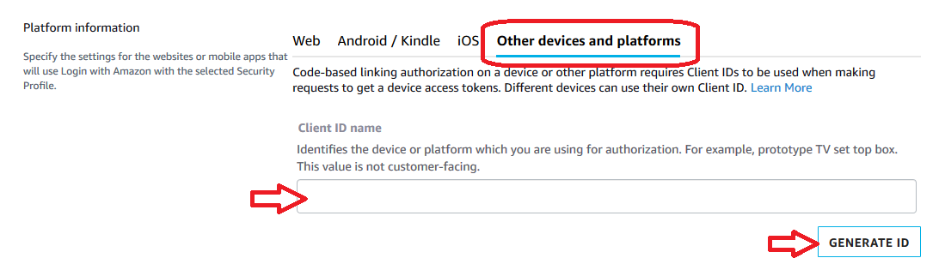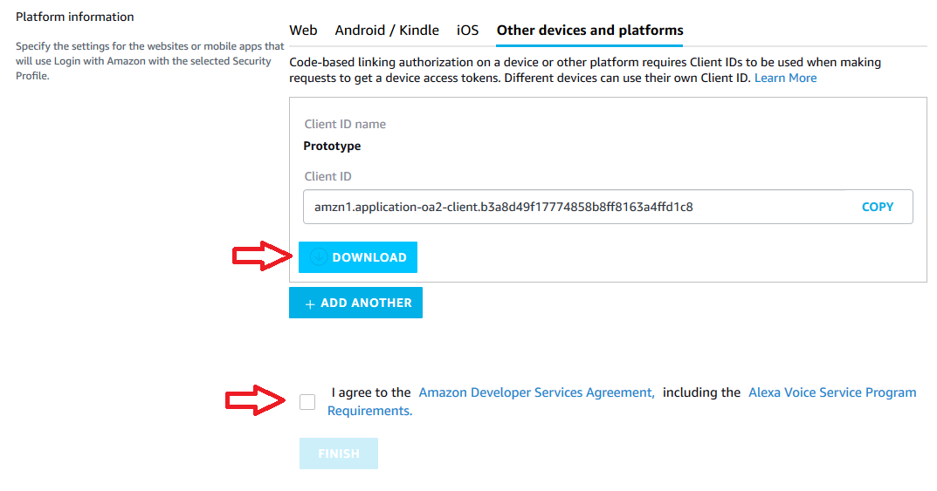

Optional: Enable your security profile for commercial distribution
Note: Skip this step if you are creating a prototype or testing the service.
If you're building a commercial product, you must provide your customer a link to your privacy policy.
- Open a web browser, and visit https://developer.amazon.com/lwa/sp/overview.html.
- Near the top of the page, select the commercial device security profile you created earlier from the drop-down menu and click the CONFIRM button.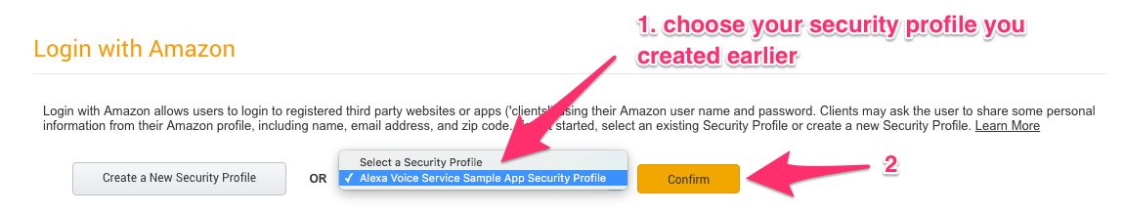
- Enter your privacy policy URL beginning with http:// or https://.
- Optional. Upload an image. It displays on the Login with Amazon consent page.
- Click SAVE.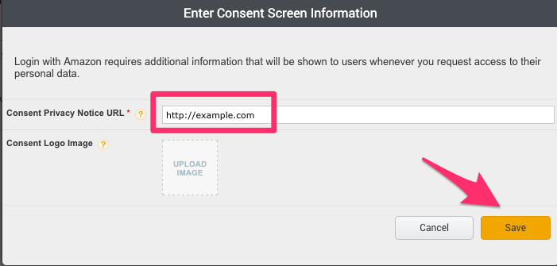
Now that you've created your product profile, it's time to get your hardware and start building.

